**Block 1**

**Augment your products in a snap**



**Drag**

**Drop**

**Check**

**Publish**



**Block 2**

## About Viewz

***“A seamless, reliable, and efficient web AR studio for an immersive, interactive, and attractive shopping experience”***

Based on our belief in the essential role of technology in the economic modern world, we decided to build a seamless, reliable, and efficient augmented reality platform for retailers, to help them promote and display their products in an immersive, interactive, and attractive way.

Viewz is a SaaS (Software as a service) AR platform that converts images of art, floors, walls, furniture and products into Augmented Reality in a seamless easy way to provide you with the ultimate try-before-buy experience for your consumers & to enhance the shopping experiences at your website.

Mobiles and taps are an essential part of the way consumers shop nowadays; to remain competitive, you need to do more than creating a mobile-responsive website, this exactly what Viewz is all about, it is an excellent option for Art, flooring, wall hangings, and furniture retailers looking to engage consumers across digital and physical channels.

Viewz web AR can seamlessly connect with any e-commerce website to pull the image’s data of flat products and retrieve it with a 3D model and ”Try It in Your Space” experience. Also simply you can drag and drop an image to create a customized experience that generates exports, batch processing, analytics, and 3D configurators, combined with an intuitive, easy-to-use interface that will help you augment your products at scale in a snap.

Viewz integrates very well with any existing marketing platforms and requires no application to download, which many consumers prefer not to do.

**Mission**:

Helping retailors get advantage of Augmented Reality technology to scale their businesses in the easiest way possible.

**Vision:**

To be the one-stop shop for all augmented reality interiors solutions.

**Block 3**

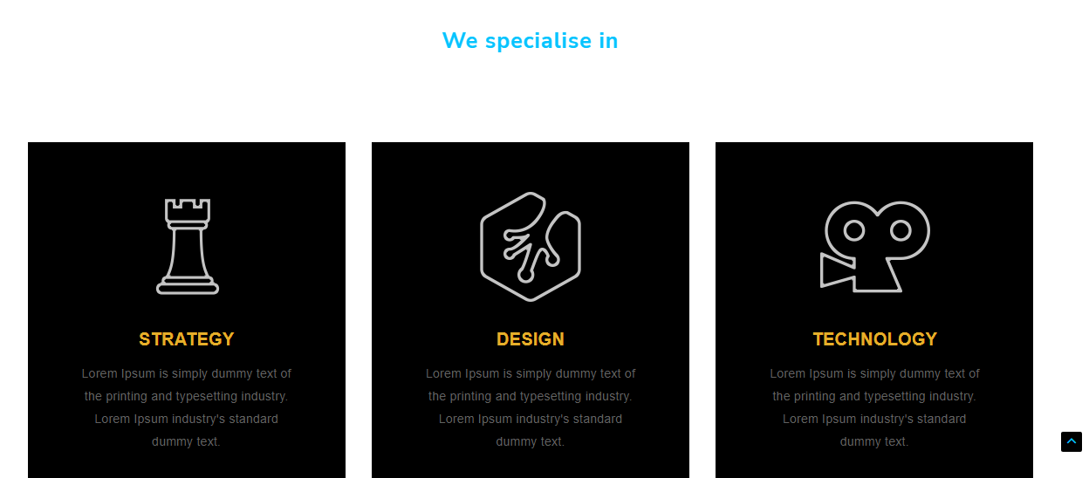

### Why Viewz?

Viewz is a one-time effort, all-time gains; by using Viewz you will bring your customers a long-lasting impactful experience and let them have real-time interactions with your products in their own environment at any time, also Viewz is:

### An innovative solution

Viewz allows retailers, especially merchants of hard-to-try or return products such as flooring products and furniture, to promote their products allowing customers to try the products in an interactive way, which will increase sales and reduce returns.

### Sustainable solution

Viewz is an eco-friendly solution that helps reduce emissions by reducing the amount of returned and exchanged merchandise through a try-before-buy AR experience, which meets most consumer demands for sustainable practices.

### Simple Effortless solution

Simple, easy, fast, and within reach platform, no need for app downloading or coding experience, all you need to do is drag, drop, test, and publish; and all your customers need to do is click, try, and then buy!

### Convenient solution

Viewz integrates seamlessly with any e-commerce website or any online shopping marketplace providing an AR “Try before you buy” experience; also, it is compatible with Android and IOS.

**Block 4**

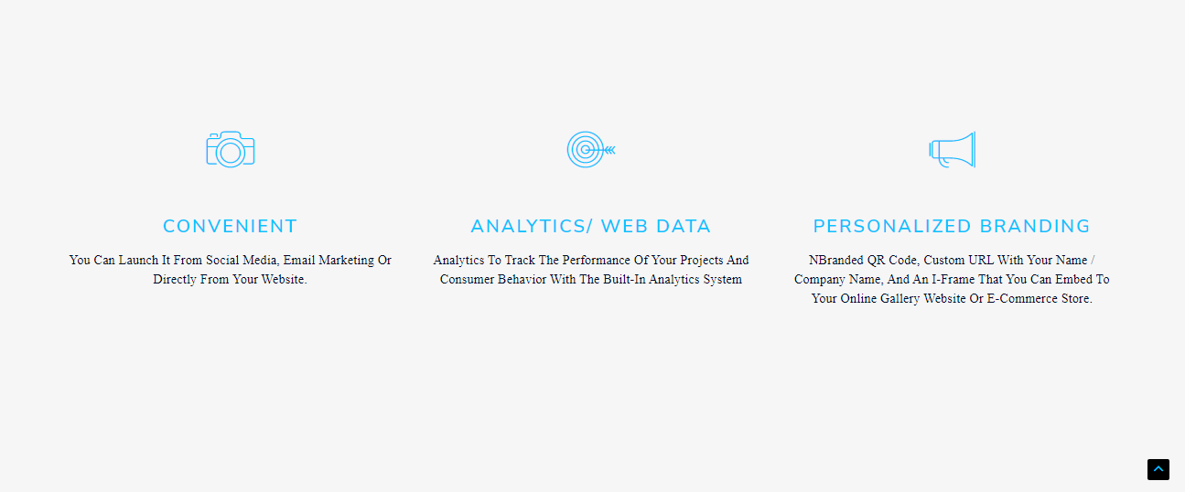

**Industries**

### Art & Design

### No purchasing decision is made on emotions as to buying an art piece or design. Buyers choose the piece that reflects their personal taste in their own space.

### With Viewz you can offer your clients the chance to view and try your art at the place or corner they wish to place it in.

### Flooring products

Most consumers prefer to try the product before buying it, but when it comes to carpets or flooring products, this option is not really available; also, you do not want your carpet to be moved many times, and you can’t offer your customer the ability to see how it will look like in reality,

But with Viewz, you will be able to do that, your customers will have the ability to ‘try-before-buy’ AR experience, not only for carpets, and rugs but also for tiles, parquet, and all flooring products! Viewz can convert a single tile image into an entire floor.

With Viewz you can give your clients the real-time experience of the entire floor.

### Wall Coverings

Provide your clients the ability to try painting, wallpaper, wall cladding, and all kinds of wall coverings in the easiest and most interactive experience with Viewz Web AR.

With Viewz you have a unique feature that enables you to convert a single piece of wallpaper pattern image into a full wallpaper AR experience, which will help your clients see exactly how it would look like in reality.

### Furniture industry

No more wondering or hesitation whether your product fits with your clients existing furniture or décor, transform your online furniture store into a selling machine with Viewz web AR.

Furniture is not a product that is easy to move, try or return, by offering your prospects the ability to view and try your furniture in their place, you are creating a strong emotional connection with your prospects, which will convert them into customers, boost sales and reduce returns.

**CTA: Get started for free**

**Not: Please don’t forget to link the read more button in the homepage to each paragraph above.**





**Block 5**

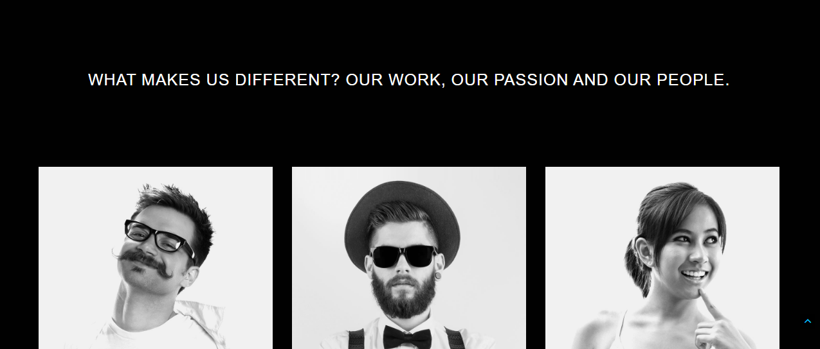

**Our team**

**Raed Mikael**

He started his career life in the interior design sector where he spend 14 years as a general manager, and completed more than 100+ successful projects for big international brands and government projects across the United Arab Emirates, he continued his passion for technology and design to scale it up to the recent trends of the Extended Reality.  
  
Raed has Completed degrees in Interior design from UK Design Academy, Business from American College of Dubai, Blockchain fundamentals and Development from Dubai university, and an Extended Reality & Metaverse expert from Blockchain council.

He is a Keynote speaker, also the founder of **Cryptabia** “A social media magazine that shares daily news about the crypto space and the recent blockchain projects and trends”.

**Amir Alshurafaa**

He started as an interior designer in a medium-sized company in UAE, then went on to become, Creative Director at one of the leading construction companies in Dubai where he met Raed and decided to follow his passion in design and technology and started AVR hub.

Certified Project manager (MBA.PM) &Interior Architect. (Bachelor).

Certified Augmented Reality (AR) expert by Google & Virtual Reality (VR) expert.

Certified senior 3D Artist. (3Ds Max) by Autodesk. Certified Graphic design & UI/UX design expert. Certified Front-end developer, 3D on the web with three.js.

**Hassan El Balkhi**

Is a highly accomplished, skilled, and knowledgeable information technology professional with extensive experience in Management systems and business processes. He is the head Of the Information Technology Department for almost 8 years in the PAN Emirates “Furniture and Home Furnishings Manufacturing” company. Hassan has a bachelor's degree in Computer Engineering and is an expert in programming languages, data structures, network and communications Customer Relationship Management (CRM), and Web Development.

**Block 6**

**Partners:**

Google

AWS “amazon”

Cloudflare

Stripe

HubSpot

**Block 7**

The same